Caregiver Reported Early Development InstrumentS (CREDI)

Long Form:
Motor, Cognitive, LanGUage, & SOcial-emotional

Date: _____________________________
Interviewee ID: _____________________
Child Date of Birth: __________________
Child Age (in Months): _______________

Interviewer Instructions:

- Based on the child’s age (in months, or M), find the item that corresponds to the child’s age-specific start point (marked by to the left of the items).
- Administer the item that corresponds to this start point, and continue with subsequent items until the caregiver responds “No” or “Don’t Know” to 5 items in a row.
  - Note: Items 9 and 102 are reverse coded, indicating that a “No” response on these items counts as a “Yes” and vice versa. These items are marked with ** as a reminder.
- After 5 consecutive “No” or “Don’t Know” responses, stop asking the items and move to Mental Health section.
- Leave all items before the start point and after the end point blank/missing.
- Remember to show caregivers the corresponding full-page illustration for those items that include an image.
- Before administering items, SAY (to caregivers):
Now I am going to ask you about the types of things your child is currently able to do. Please answer "yes" or "no" to these questions. If you are unsure, you can also answer by saying “don’t know.” Please keep in mind that children learn and grow at different rates, so it is fine if your child can't yet do these things. Some of these skills children only achieve at older ages. If there is any question you feel uncomfortable answering, please let me know and we can move to the next question.
 | Item # | Item | Image | Response
0-5 M | LF1 | When lying on his/her back, does the child move his/her arms and legs? | 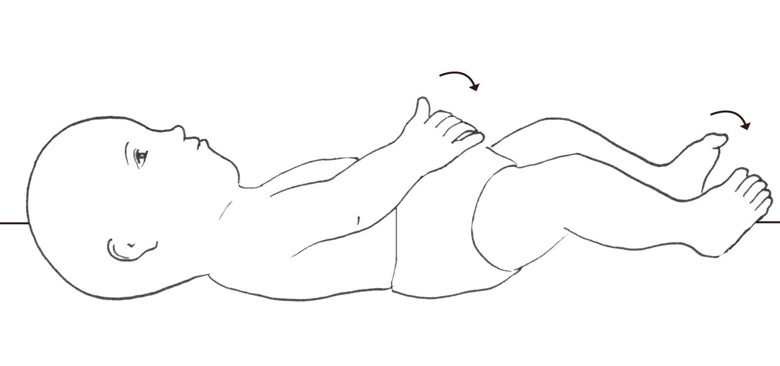 | Yes | No | DK
0-5 M | LF2 | Does the child bring his/her hand to his/her mouth? | 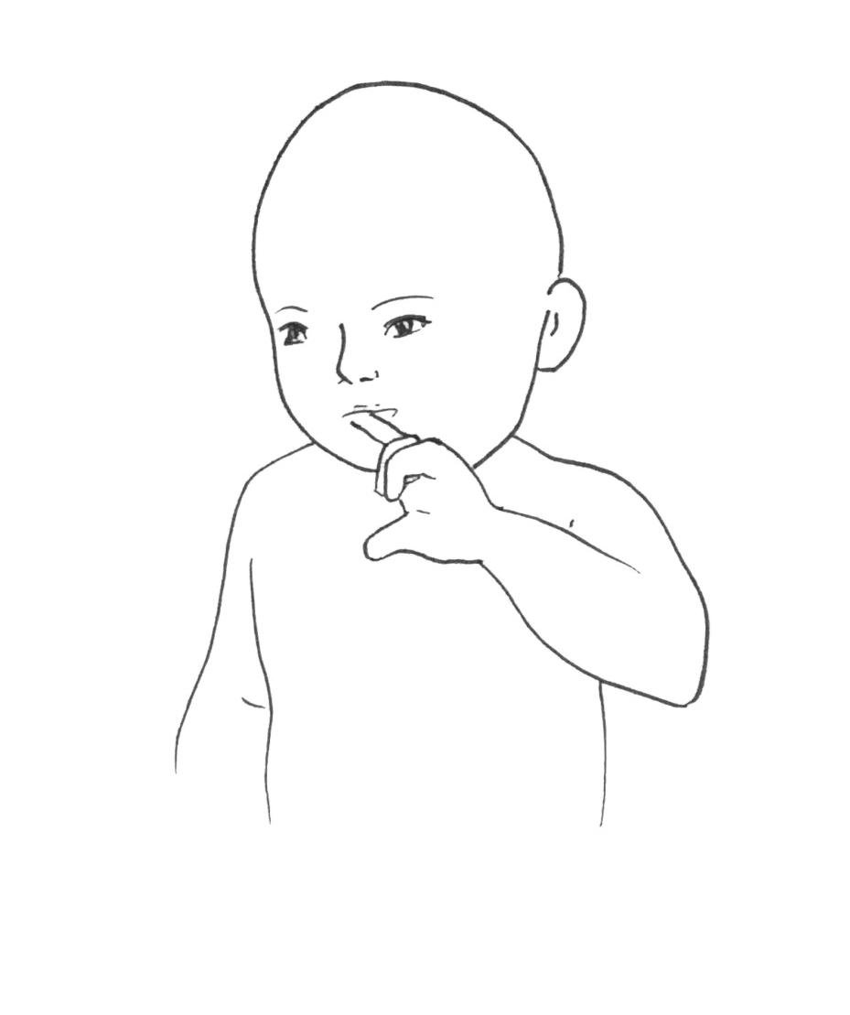 | Yes | No | DK
0-5 M | LF3 | Does the child laugh? |  | Yes | No | DK
0-5 M | LF4 | Does the child smile when others smile at him/her? |  | Yes | No | DK
0-5 M | LF5 | Does the child sometimes suck his/her thumb or fingers? |  | Yes | No | DK
6-11 M | LF6 | Does the child grasp onto a small object (e.g., your finger, a spoon) when put in his/her hand? | 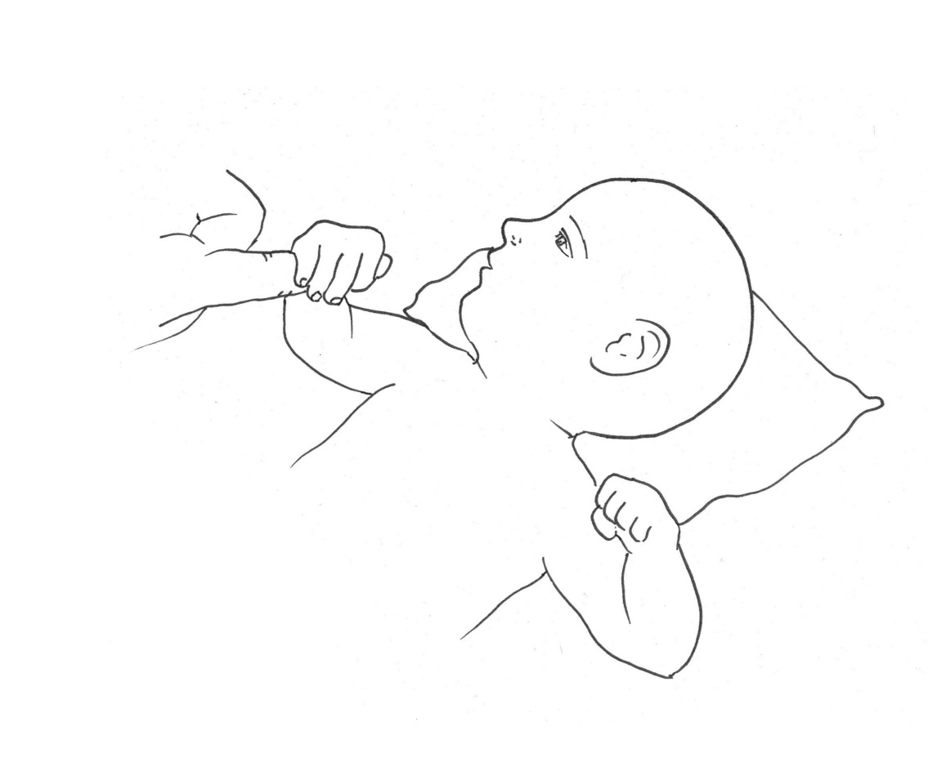 | Yes | No | DK
6-11 M | LF7 | Can the child bring his/her hands together? | 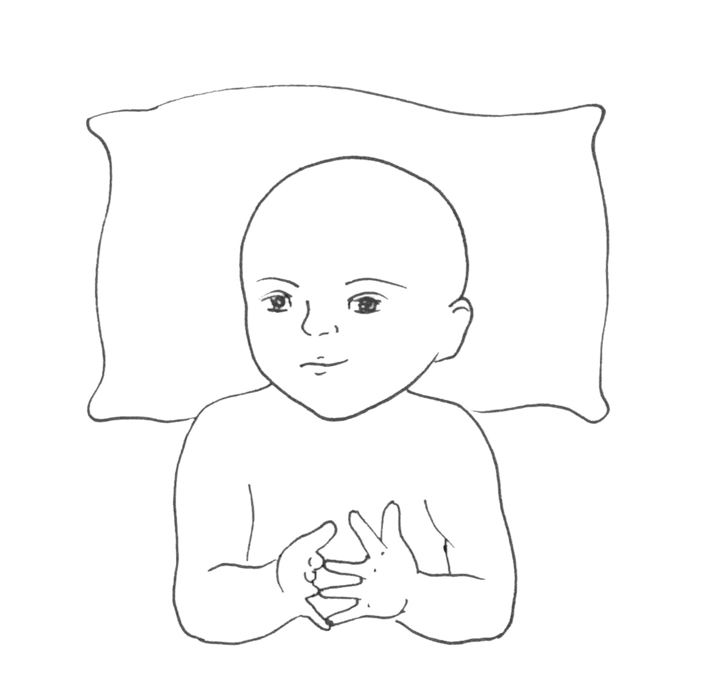 | Yes | No | DK
6-11 M | LF8 | Does the child recognize you or other family members (e.g., smile when they enter a room or move toward them)? |  | Yes | No | DK
6-11 M | LF9 | **Does the child hold his/her hands in fists all the time? | 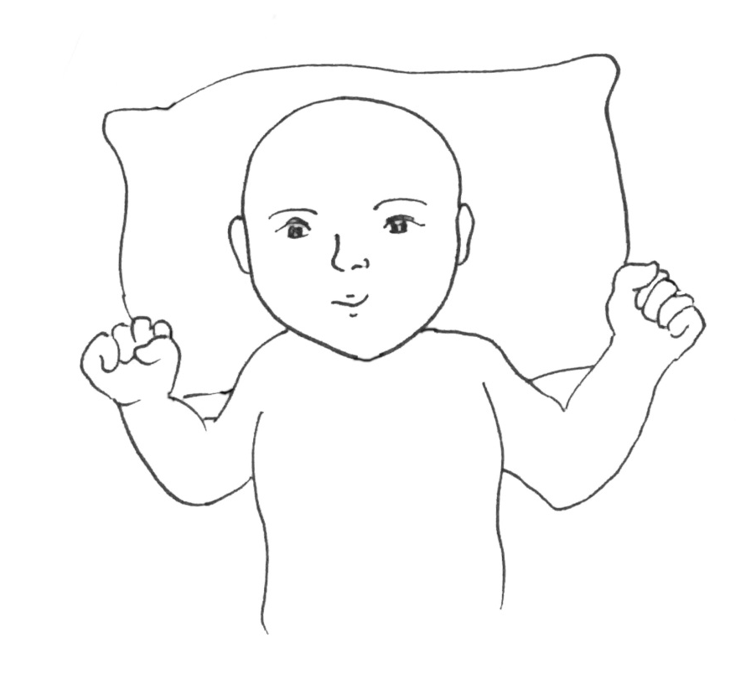 | Yes | No | DK
6-11 M | LF10 | Does the child show interest in new objects that are put in front of him/her by reaching out for them? |  | Yes | No | DK
12-17 M | LF11 | Can the child roll from his/her back to stomach, or stomach to back, on his/her own? | 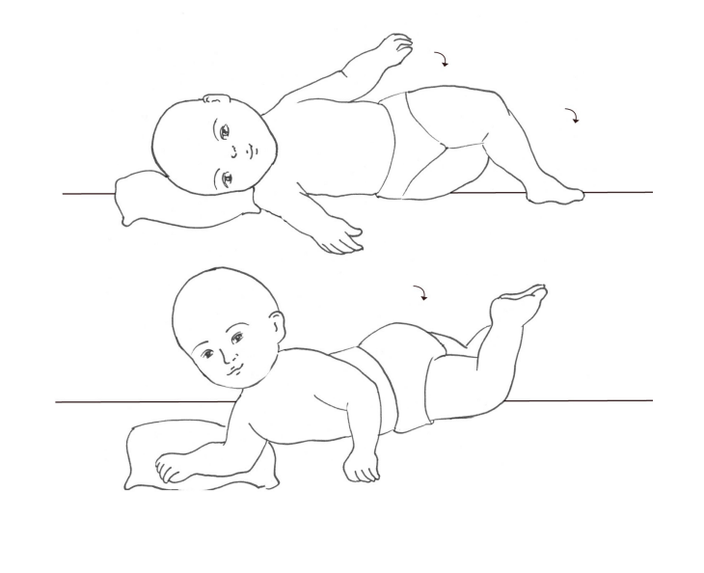 | Yes | No | DK
12-17 M | LF12 | Does the child show interest in new objects by trying to put them in his/her mouth? |  | Yes | No | DK
12-17 M | LF13 | Does the child often show affection toward others (e.g., hugging parents, brothers, or sisters)? |  | Yes | No | DK
12-17 M | LF14 | Can the child pick up a small object (e.g., a small toy or small stone) using just one hand? | 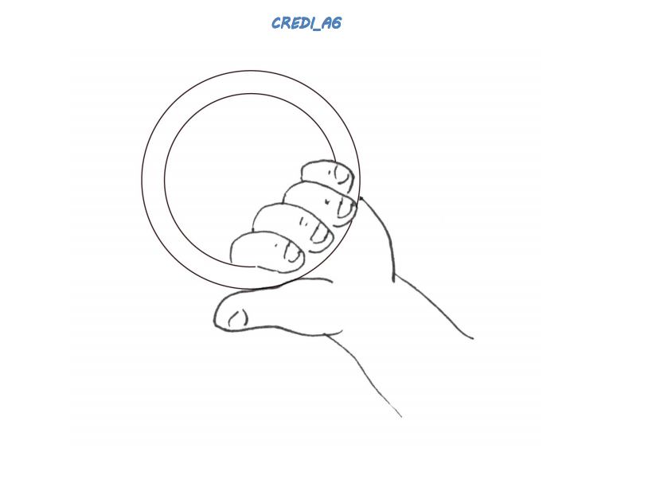 | Yes | No | DK
12-17 M | LF15 | Does the child look for an object of interest when it is removed from sight or hidden from him/her (e.g., put under a cover, behind another object)? |  | Yes | No | DK
12-17 M | LF16 | When lying on his/her back, does the child grab his/her feet? | 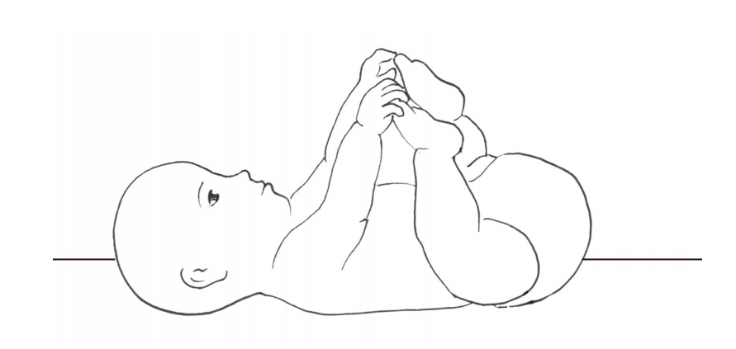 | Yes | No | DK
12-17 M | LF17 | Can the child make simple sounds like "ba," "da," or "do?" |  | Yes | No | DK
12-17 M | LF18 | When lying on his/her stomach, can the child hold his/her head and chest off the ground using only his/her hands and arms for support? | 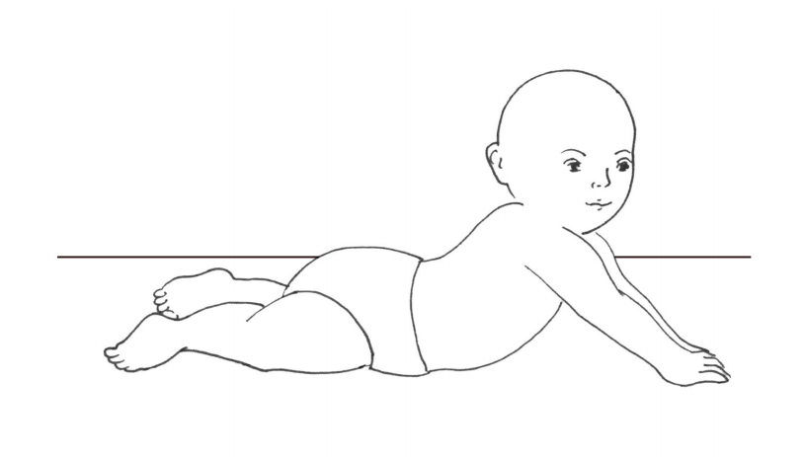 | Yes | No | DK
12-17 M | LF19 | Does the child play by tapping an object on the ground or a table? |  | Yes | No | DK
12-17 M | LF20 | Can the child hold him/herself in a sitting position without help or support for longer than a few seconds? | 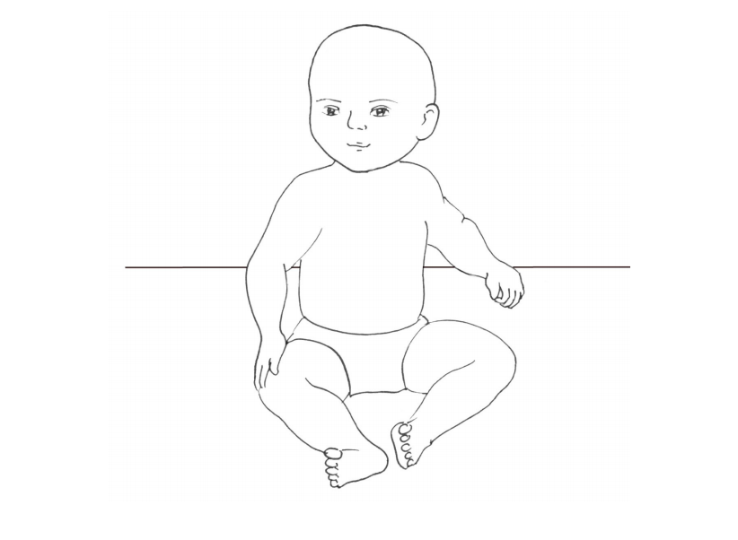 | Yes | No | DK
12-17 M | LF21 | Does the child intentionally move or change his/her position to get objects that are out of reach? |  | Yes | No | DK
12-17 M | LF22 | Does the child look at an object when someone says "look!" and points to it? |  | Yes | No | DK
12-17 M | LF23 | Does the child recognize his/her name or nickname? That is, does he/she respond differently to his/her name than to other sounds or words? |  | Yes | No | DK
12-17 M | LF24 | When you talk to the child, does he/she respond by making a sound (e.g., "ba," "da," or "do") or by saying a word? |  | Yes | No | DK
12-17 M | LF25 | Can the child crawl, roll, or scoot forward on his/her own? | 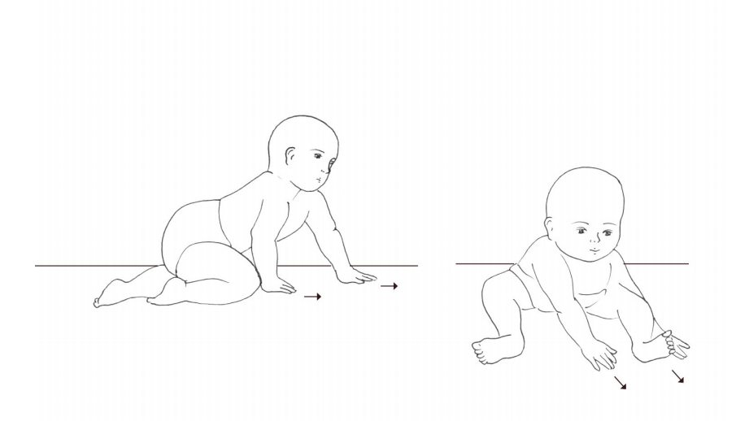 | Yes | No | DK
12-17 M | LF26 | Can the child pick up and eat small pieces of food with his/her fingers? | 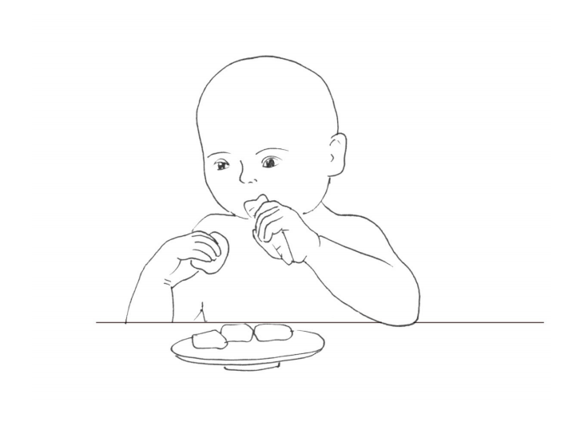 | Yes | No | DK
12-17 M | LF27 | Can the child transfer a small object (e.g., a small toy or small stone) from one hand to the other? | 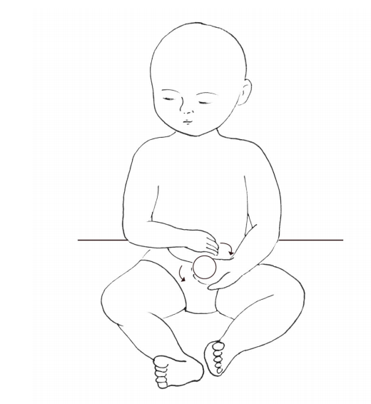 | Yes | No | DK
12-17 M | LF28 | Does the child clap his/her hands together? | 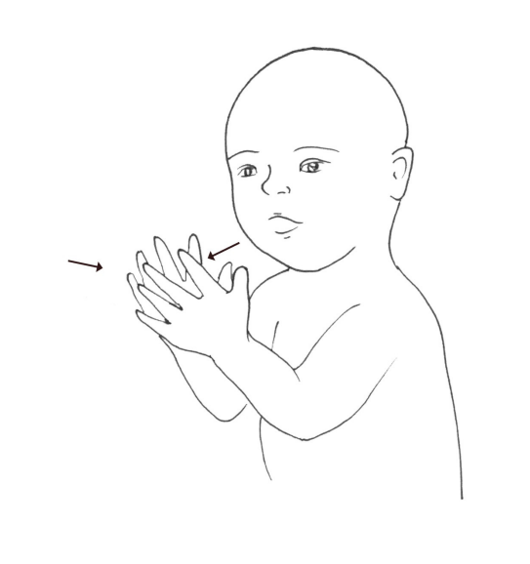 | Yes | No | DK
18-23 M | LF29 | Can the child maintain a standing position while holding on to a person or object (e.g., wall or furniture)? | 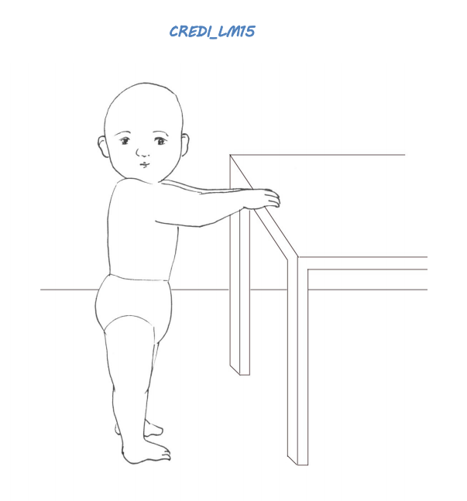 | Yes | No | DK
18-23 M | LF30 | Can the child use gestures to indicate what he/she wants (e.g., put arms up to indicate that he/she wants to be held, or point to water)? |  | Yes | No | DK
18-23 M | LF31 | Can the child pick up a small object (e.g., a small toy or small stone) with just his/her thumb and a finger? | 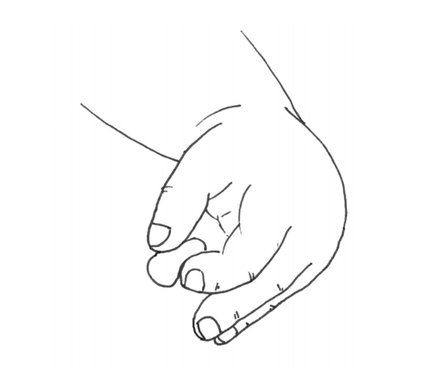 | Yes | No | DK
18-23 M | LF32 | Can the child pick up and drop a small object (e.g., a small toy or small stone) into a bucket or bowl while sitting? | 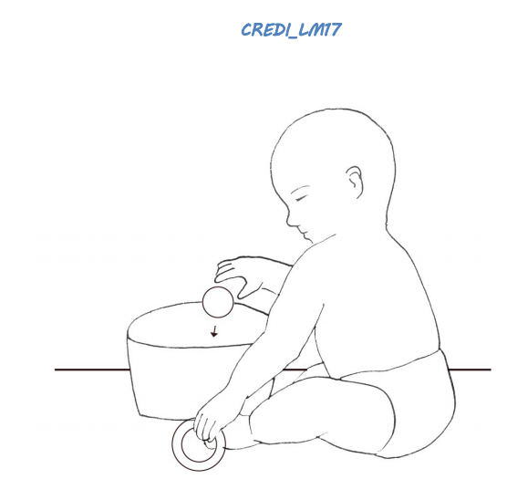 | Yes | No | DK
18-23 M | LF33 | Can the child throw a small ball or small stone in a forward direction using his/her hand? | 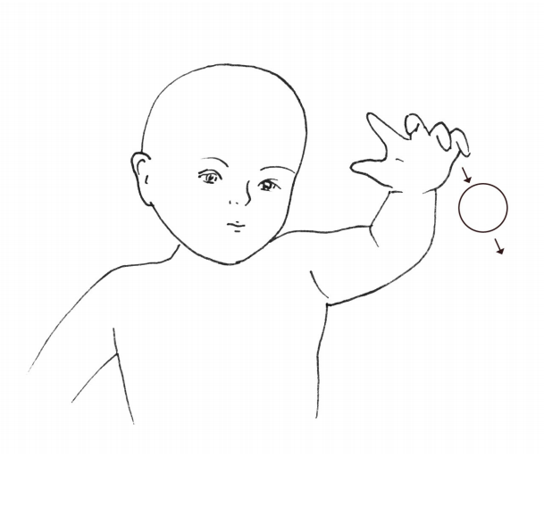 | Yes | No | DK
18-23 M | LF34 | Can the child walk several steps while holding on to a person or object (e.g., wall or furniture)? | 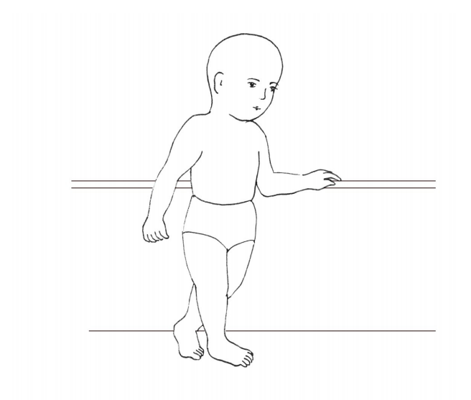 | Yes | No | DK
18-23 M | LF35 | Can the child say one or more words (e.g., names like "Mama" or "ba" for "ball")? |  | Yes | No | DK
18-23 M | LF36 | Can the child maintain a standing position on his/her own, without holding on or receiving support? | 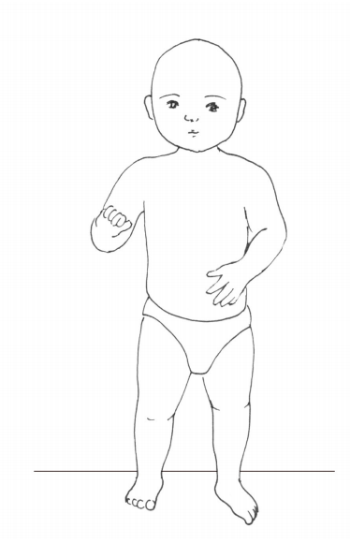 | Yes | No | DK
18-23 M | LF37 | Can the child follow simple directions (e.g., “Stand up" or "Come here”)? |  | Yes | No | DK
18-23 M | LF38 | Does the child watch what other children do and try to copy them? |  | Yes | No | DK
24-29 M | LF39 | Can the child sit or play on his/her own for at least 20 minutes? |  | Yes | No | DK
24-29 M | LF40 | Can the child walk several steps on his/her own, without holding on or receiving support? | 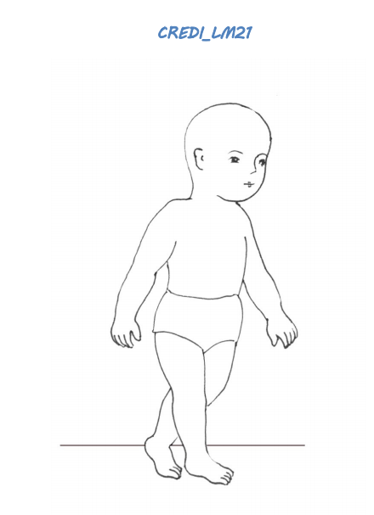 | Yes | No | DK
24-29 M | LF41 | Can the child bend down to the ground and stand up again without falling and without holding onto a person or object? | 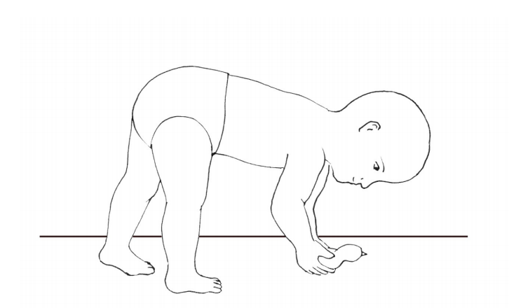 | Yes | No | DK
24-29 M | LF42 | Does the child ask you for help using signs or words when he/she cannot do something on his/her own (e.g., to reach an object up high)? |  | Yes | No | DK
24-29 M | LF43 | Does the child try to repeat sounds or words said by other people? |  | Yes | No | DK
24-29 M | LF44 | Can the child climb onto an object such as a chair or bench? | 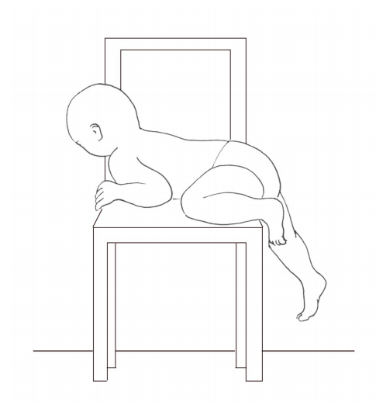 | Yes | No | DK
24-29 M | LF45 | Can the child figure out how to turn a spoon or object if you give it to him/her the wrong way around? |  | Yes | No | DK
24-29 M | LF46 | Does the child stop at least briefly when told “no” or “stop that"? |  | Yes | No | DK
24-29 M | LF47 | Can the child kick a ball or other round object forward using his/her foot? | 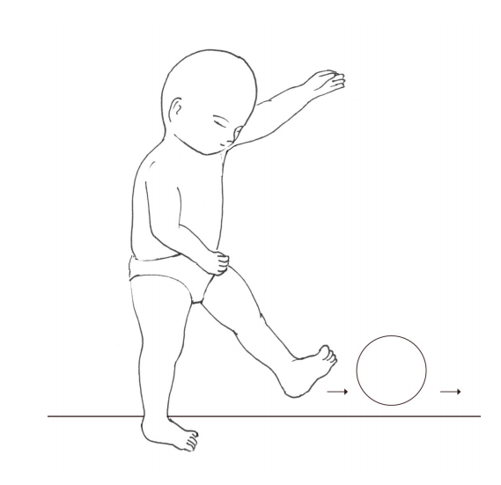 | Yes | No | DK
24-29 M | LF48 | Can the child point to a person or object when asked (e.g., “Where is mama?" or "Where is the ball?")? |  | Yes | No | DK
24-29 M | LF49 | Can the child drink from a cup (without a lid) on his/her own without spilling? | 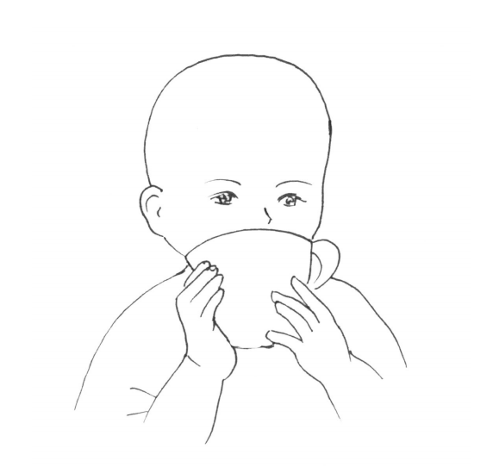 | Yes | No | DK
24-29 M | LF50 | Does the child imitate animal or other sounds (e.g., "vroom" for a car, "moo" for a cow)? |  | Yes | No | DK
24-29 M | LF51 | Can the child run more than a few steps without falling or bumping into objects? | 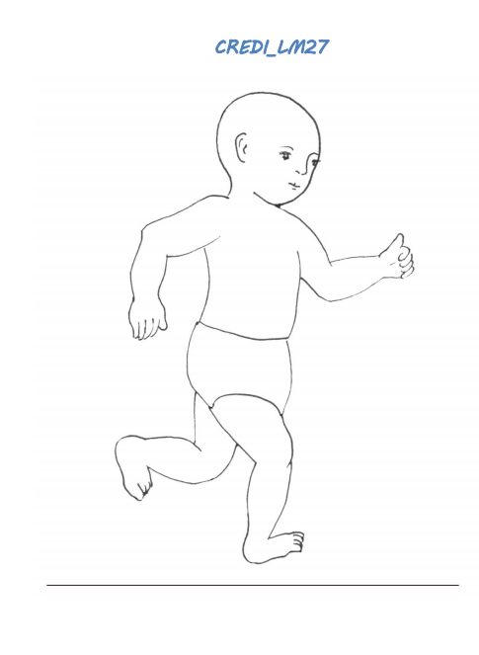 | Yes | No | DK
30-35 M | LF52 | Can the child draw a line or shape on paper with a pen or crayon, or in the dirt with a stick? | 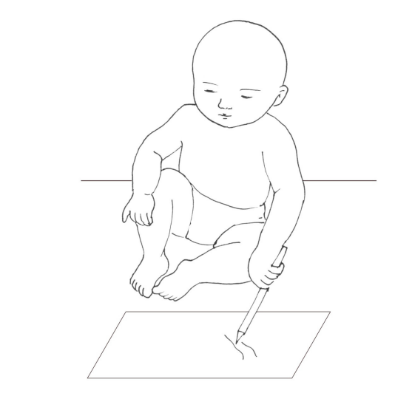 | Yes | No | DK
30-35 M | LF53 | Can the child answer simple questions (e.g., “Do you want water?”) by saying "yes" or "no", rather than nodding? |  | Yes | No | DK
30-35 M | LF54 | Can the child stack three or more small objects (e.g., blocks, cups, bottle caps) on top of each other? | 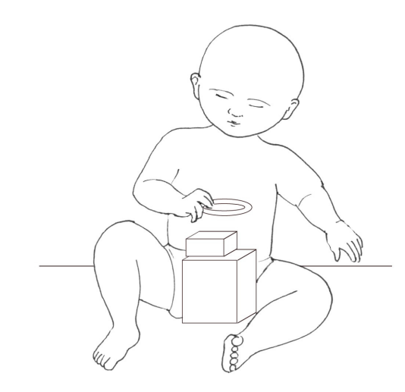 | Yes | No | DK
30-35 M | LF55 | Does the child imitate others' behaviors (e.g., washing hands or dishes)? |  | Yes | No | DK
30-35 M | LF56 | Does the child sometimes share things (e.g., food, toys) with others without being told? |  | Yes | No | DK
30-35 M | LF57 | Can the child follow orders or instructions that have more than one part (e.g., "Go get water and go to bed")? |  | Yes | No | DK
30-35 M | LF58 | Can the child say five or more separate words (e.g., names like "Mama" or objects like "ball")? |  | Yes | No | DK
30-35 M | LF59 | Is the child kind to younger children (e.g., speaks to them nicely and touches them gently)? |  | Yes | No | DK
30-35 M | LF60 | Can the child walk on an uneven surface (e.g., a bumpy or steep road) without falling? | 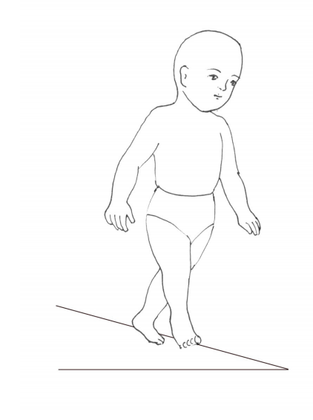 | Yes | No | DK
30-35 M | LF61 | Does the child listen to someone telling a story with interest? |  | Yes | No | DK
30-35 M | LF62 | Can the child ask for something (e.g., food, water) by name when he/she wants it? |  | Yes | No | DK
30-35 M | LF63 | Does the child involve others in play (i.e., play interactive games with other children)? |  | Yes | No | DK
30-35 M | LF64 | Can the child correctly name at least one family member other than mom and dad (e.g., name of brother, sister, aunt, uncle)? |  | Yes | No | DK
30-35 M | LF65 | Does the child play by pretending objects are something else (e.g., imagining a bottle is a doll, a stone is a car, or a spoon is an airplane)? |  | Yes | No | DK
30-35 M | LF66 | Does the child show sympathy or look concerned when others are hurt or sad? |  | Yes | No | DK
30-35 M | LF67 | Can the child walk backwards? | 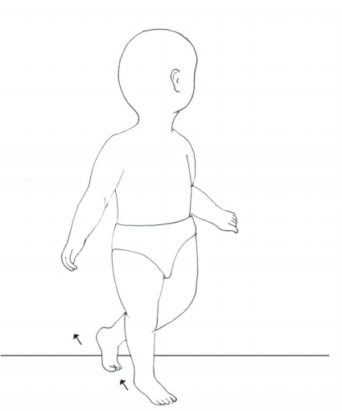 | Yes | No | DK
30-35 M | LF68 | Does the child show curiosity to learn new things (e.g., by asking questions or exploring a new area)? |  | Yes | No | DK
30-35 M | LF69 | Can the child feed him/herself using a spoon or other utensil without spilling? | 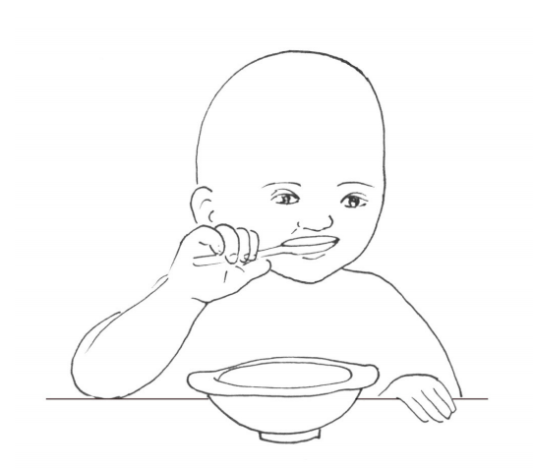 | Yes | No | DK
30-35 M | LF70 | Can the child concentrate on one task (e.g., playing with friends, eating meal) for 20 minutes? |  | Yes | No | DK
30-35 M | LF71 | Does the child know the names of at least two body parts (e.g., arm, eye, or nose)? |  | Yes | No | DK
30-35 M | LF72 | If you show the child an object he/she knows well (e.g., a cup or animal), can he/she consistently name it? |  | Yes | No | DK
30-35 M | LF73 | Can the child speak using short sentences of two words that go together (e.g., “Mama go” or "Dada eat”)? |  | Yes | No | DK
30-35 M | LF74 | Can the child use a tool (e.g., a stick or spoon) to reach objects that are far away? |  | Yes | No | DK
30-35 M | LF75 | Can the child indicate when he/she needs to go to the toilet? |  | Yes | No | DK
30-35 M | LF76 | Can the child say ten or more separate words (e.g., names like "Mama" or objects like "ball")? |  | Yes | No | DK
30-35 M | LF77 | Can the child remove an item of clothing (e.g., take off his/her shirt)? | 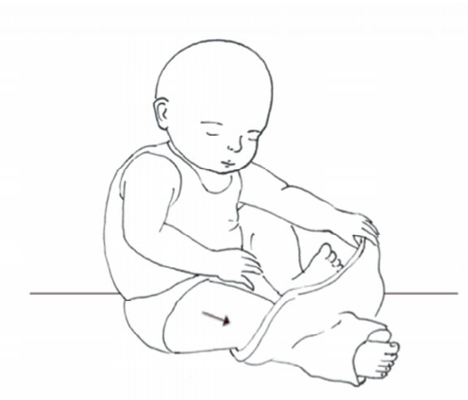 | Yes | No | DK
30-35 M | LF78 | Can the child tell you when he/she is tired or hungry? |  | Yes | No | DK
30-35 M | LF79 | Does the child usually finish an activity he/she enjoys (e.g., a game or book)? |  | Yes | No | DK
30-35 M | LF80 | Can the child easily switch back and forth between activities (e.g., go back to a game after being interrupted)? |  | Yes | No | DK
30-35 M | LF81 | Can the child sing a short song or repeat parts of a rhyme from memory by him/herself? |  | Yes | No | DK
30-35 M | LF82 | Can the child jump with both feet leaving the ground? | 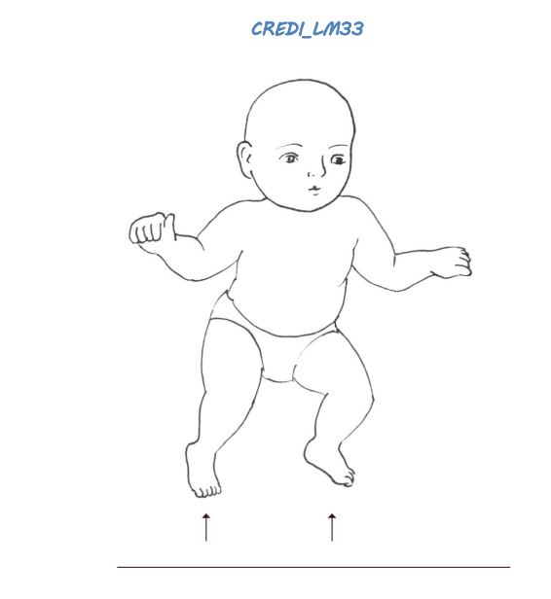 | Yes | No | DK
30-35 M | LF83 | Can the child speak using sentences of three or more words that go together (e.g., "I want water" or "The house is big")? |  | Yes | No | DK
30-35 M | LF84 | Can the child whisper? |  | Yes | No | DK
30-35 M | LF85 | Does the child greet neighbors or other people he/she knows without being told (e.g., by saying hello or gesturing hello)? |  | Yes | No | DK
30-35 M | LF86 | Can the child unscrew the lid from a bottle or jar? | 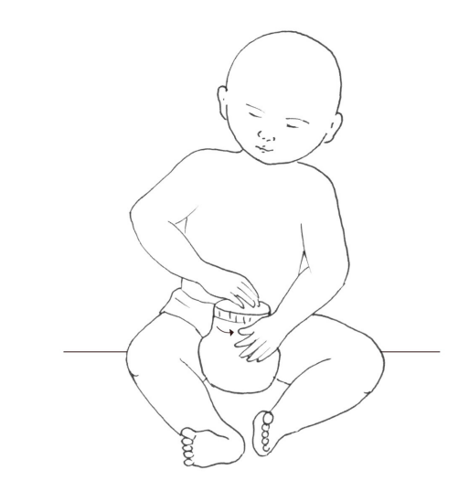 | Yes | No | DK
30-35 M | LF87 | Can the child correctly ask questions using any of the words "what," "which," "where," or "who"? |  | Yes | No | DK
30-35 M | LF88 | Can the child correctly use any of the words "I," "you," "she," or "he" (e.g., "I go to store," or "He eats rice")? |  | Yes | No | DK
30-35 M | LF89 | Does the child pronounce most of his/her words correctly? |  | Yes | No | DK
30-35 M | LF90 | Can the child count up to five objects (e.g., fingers, people)? |  | Yes | No | DK
30-35 M | LF91 | Does the child ask about familiar people other than parents when they are not there (e.g., "Where is the neighbor?")? |  | Yes | No | DK
30-35 M | LF92 | If you show the child two objects or people of different size, can he/she tell you which one is the big one and which is the small one? |  | Yes | No | DK
30-35 M | LF93 | Can the child stand on one foot for several seconds without holding on to a person or object (e.g., wall or furniture)? | 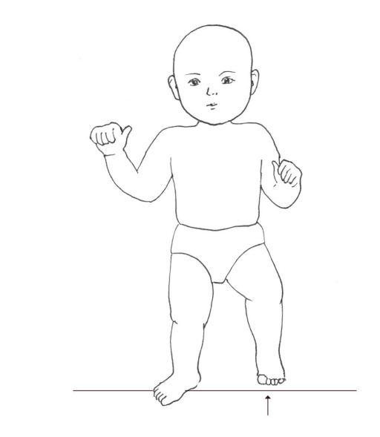 | Yes | No | DK
30-35 M | LF94 | Can the child identify at least one color (e.g., red, blue, yellow)? |  | Yes | No | DK
30-35 M | LF95 | Does the child regularly use describing words such as "fast," "short," "hot," "fat," or "beautiful" correctly? |  | Yes | No | DK
30-35 M | LF96 | If you point to an object, can the child correctly use the words "on," "in," or "under" to describe where it is (e.g., "The cup is on the table" instead of "The cup is in the table.") |  | Yes | No | DK
30-35 M | LF97 | Can the child explain in words what common objects like a cup or chair are used for? |  | Yes | No | DK
30-35 M | LF98 | Can the child dress him/herself (e.g., put on his/her pants and shirt without help)? | 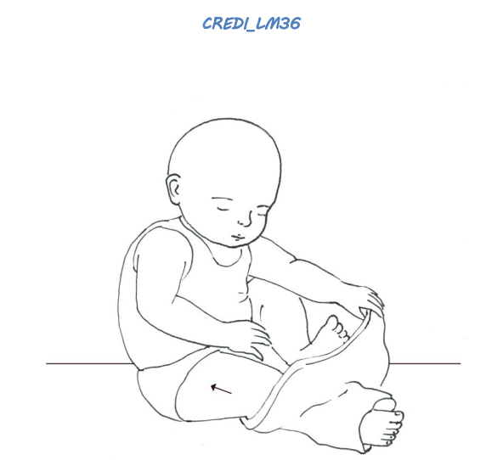 | Yes | No | DK
30-35 M | LF99 | Does the child ask "why" questions (e.g., "Why are you tall?")? |  | Yes | No | DK
30-35 M | LF100 | If you ask the child to give you three objects (e.g., stones, beans), does the child give you the correct amount? |  | Yes | No | DK
30-35 M | LF101 | Does the child usually put objects or toys back where they belong after using them? |  | Yes | No | DK
30-35 M | LF102 | **Does the child frequently act impulsively or without thinking (e.g., running into the street without looking)? |  | Yes | No | DK
30-35 M | LF103 | Does the child sometimes save things like candy or new toys for the future? |  | Yes | No | DK
30-35 M | LF104 | Can the child say what others like or dislike (e.g., "Mama doesn't like fruit," "Papa likes football")? |  | Yes | No | DK
30-35 M | LF105 | Can the child fasten and unfasten buttons without help? | 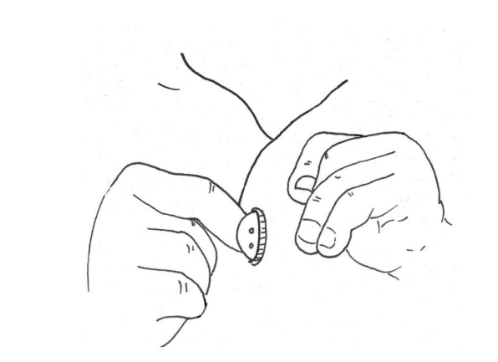 | Yes | No | DK
30-35 M | LF106 | Can the child talk about things that will happen in the future using correct language (e.g., "Tomorrow he will attend school" or "Next week we will go to the market")? |  | Yes | No | DK
30-35 M | LF107 | Can the child talk about things that have happened in the past using correct language (e.g., "Yesterday I played with my friend" or "Last week she went to the market")? |  | Yes | No | DK
30-35 M | LF108 | Does the child know the names of any letters (e.g., A, B, C)? |  | Yes | No | DK

Long form: mental health

Interviewer Instructions:

- Administer all items for all children, regardless of age.
- Before administering items, SAY (to caregivers):

We have just a few more questions to answer. The rules for these are the same. Please continue to answer with "yes", "no," or "don't know."
0-5 M  6-11 M | Item # | Item | Response
0-5 M  6-11 M | LMH1 | Does the child often cry for no reason (e.g., when he/she is not hungry or tired)? | Yes | No | DK
0-5 M  6-11 M | LMH2 | Does the child frequently complain of headaches or stomachaches when he/she is not physically ill? | Yes | No | DK
0-5 M  6-11 M | LMH3 | Does the child become upset when you are not with him/her? | Yes | No | DK
0-5 M  6-11 M | LMH4 | Does the child become very shy, afraid, or upset around strangers, even when you're with him/her? | Yes | No | DK
0-5 M  6-11 M | LMH5 | Does the child cling excessively to his/her caregiver, even in a safe setting? | Yes | No | DK
0-5 M  6-11 M | LMH6 | Can the child sit still when asked to by an adult (e.g., for two minutes)? | Yes | No | DK
0-5 M  6-11 M | LMH7 | Does the child cry or whine when he/she is made to wait for something he/she wants (e.g., toy or food)? | Yes | No | DK
0-5 M  6-11 M | LMH8 | Does the child often kick, bite, or hit other children or adults? | Yes | No | DK
0-5 M  6-11 M | LMH9 | Does the child become extremely withdrawn or shy in new situations? | Yes | No | DK

