Caregiver Reported Early Development Instruments (CREDI)

Short Form: 0-5 MONTHS

Date: _____________________________
Interviewee ID: _____________________
Child Date of Birth: __________________
Child Age (in Months): _______________

Assessor Instructions:

- Administer the set of items that corresponds with the child’s age band.
- Remember to show caregivers the corresponding full-page illustration for those items that include an image.
- Before administering items, SAY (to caregivers):
Now I am going to ask you about the types of things your child is currently able to do. Please answer "yes" or "no" to these questions. If you are unsure, you can also answer by saying “don’t know.” Please keep in mind that children learn and grow at different rates, so it is fine if your child can't yet do these things. Some of these skills children only achieve at older ages. If there is any question you feel uncomfortable answering, please let me know and we can move to the next question.

Item # | Item | Image | Response
A1 | Does the child smile when others smile at him/her? |  | Yes | No | DK
A2 | Does the child grasp onto a small object (e.g., your finger, a spoon) when put in his/her hand? | 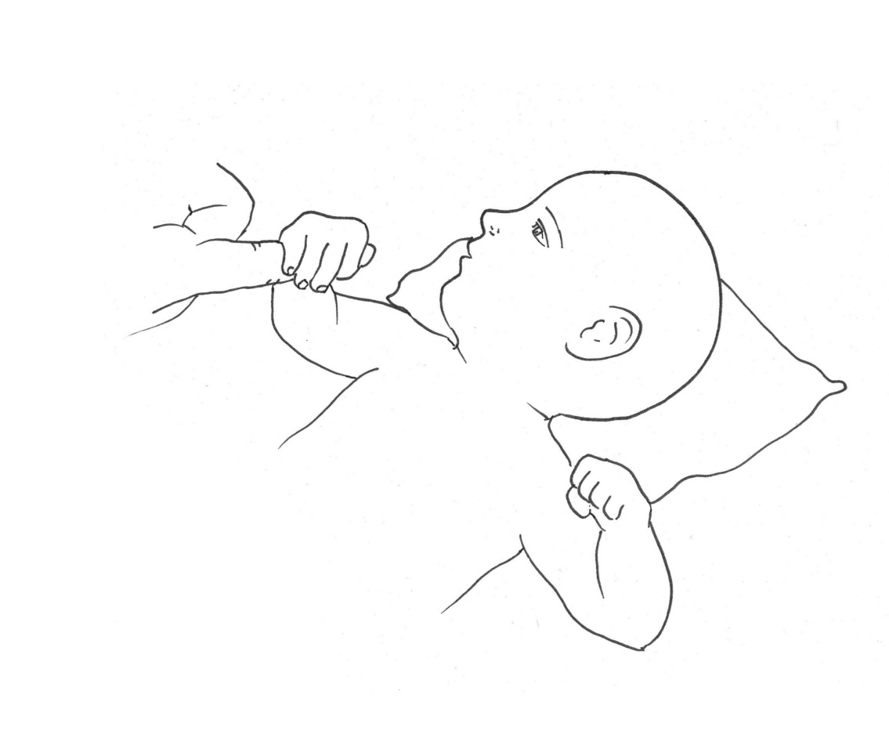 | Yes | No | DK
A3 | Does the child recognize you or other family members (e.g., smile when they enter a room or move toward them)? |  | Yes | No | DK
A4 | Does the child show interest in new objects by trying to put them in his/her mouth? |  | Yes | No | DK
A5 | When lying on his/her stomach, can the child hold his/her head and chest off the ground using only his/her hands and arms for support? | 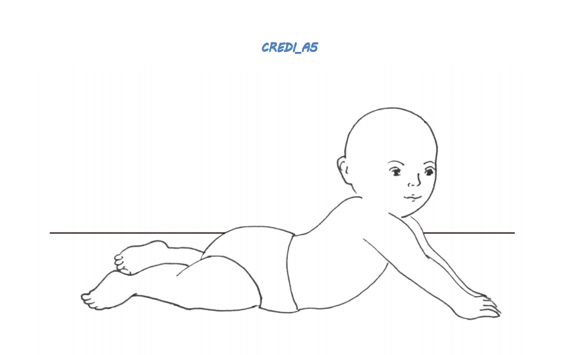 | Yes | No | DK
A6 | Can the child pick up a small object (e.g., a small toy or small stone) using just one hand? | 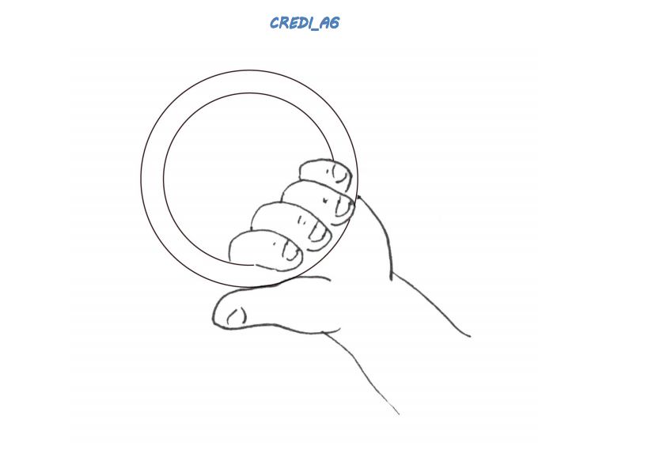 | Yes | No | DK
A7 | When lying on his/her back, does the child grab his/her feet? | 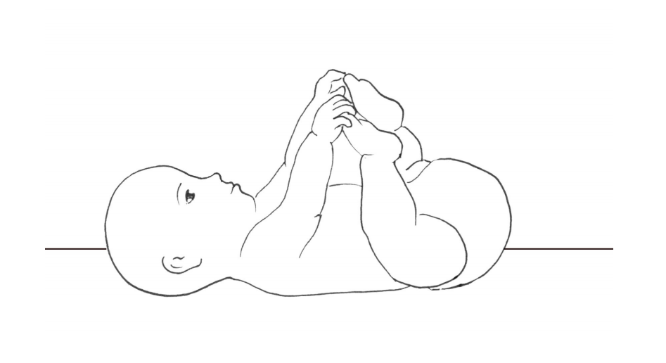 | Yes | No | DK
A8 | Does the child look at an object when someone says "look!" and points to it? |  | Yes | No | DK
A9 | Does the child look for an object of interest when it is removed from sight or hidden? |  | Yes | No | DK
A10 | Does the child intentionally move or change his/her position to get objects that are out of reach? |  | Yes | No | DK
A11 | Does the child play by tapping an object on the ground or a table? |  | Yes | No | DK
A12 | Can the child hold him/herself in a sitting position without help or support for longer than a few seconds? | 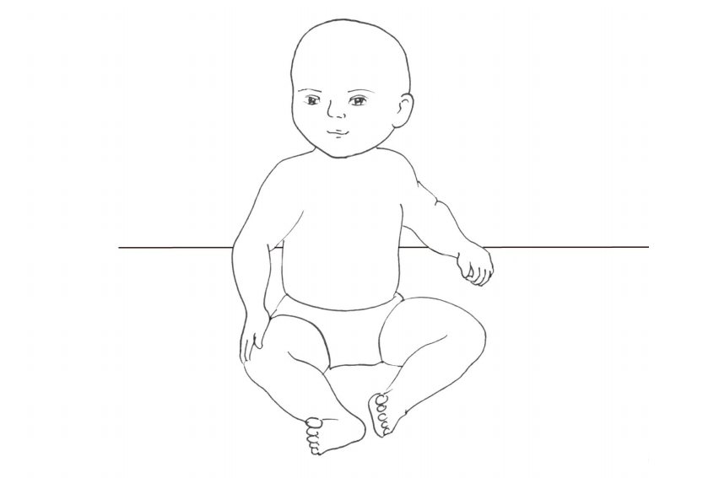 | Yes | No | DK
A13 | Can the child pick up and eat small pieces of food with his/her fingers? | 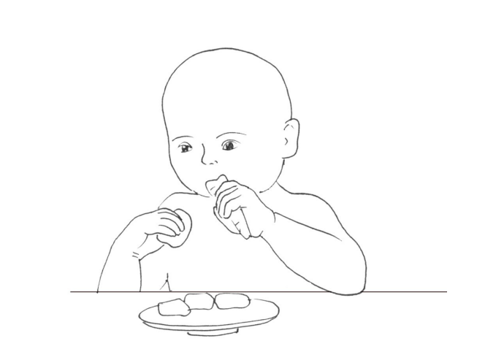 | Yes | No | DK
A14 | Can the child transfer a small object (e.g., a small toy or small stone) from one hand to the other? | 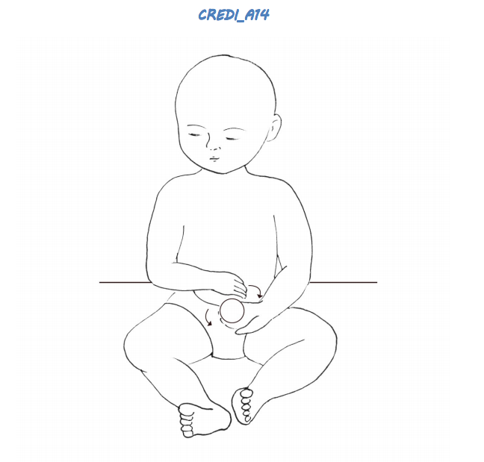 | Yes | No | DK
A15 | Can the child use gestures to indicate what he/she wants (e.g., put arms up to indicate that he/she wants to be held, or point to water)? |  | Yes | No | DK
A16 | Can the child crawl, roll, or scoot forward on his/her own? | 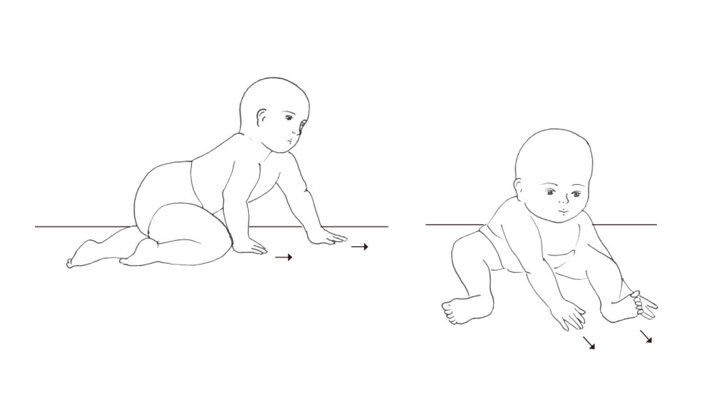 | Yes | No | DK
A17 | Can the child throw a small ball or small stone in a forward direction using his/her hand? | 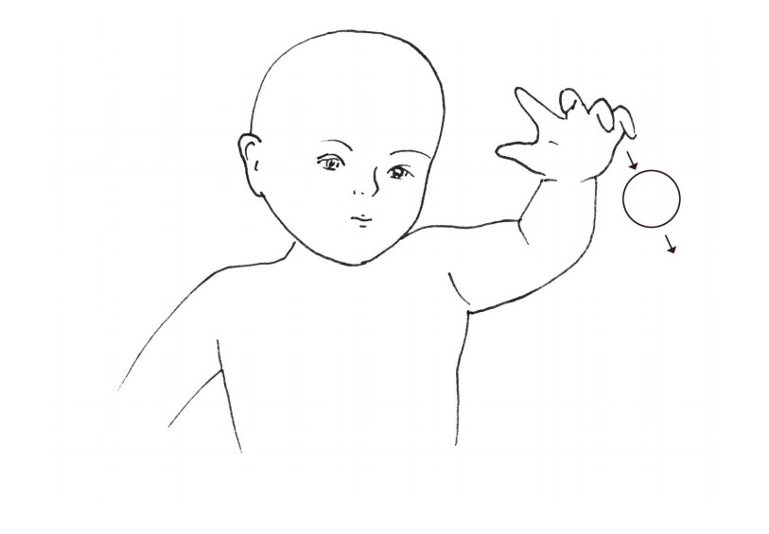 | Yes | No | DK
A18 | Can the child pick up and drop a small object (e.g., a small toy or small stone) into a bucket or bowl while sitting? | 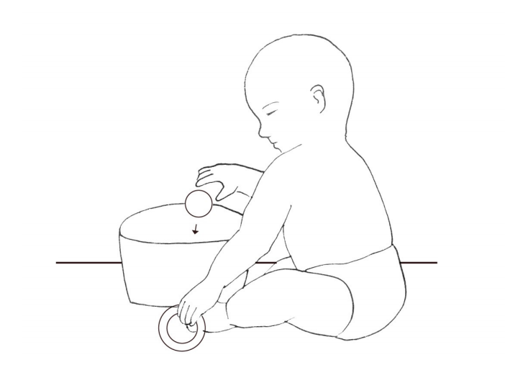 | Yes | No | DK
A19 | Can the child say one or more words (e.g., names like "Mama" or "ba" for "ball")? |  | Yes | No | DK
A20 | Can the child walk several steps while holding on to a person or object (e.g., wall or furniture)? | 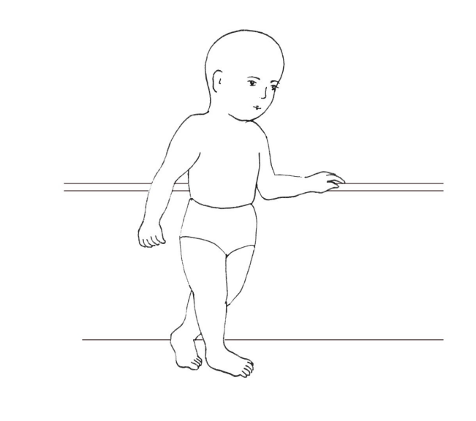 | Yes | No | DK

Caregiver Reported Early Development InstrumentS (CREDI)

Short Form: 6-11 MONTHS

Date: _____________________________
Interviewee ID: _____________________
Child Date of Birth: __________________
Child Age (in Months): _______________

Assessor Instructions:

- Administer the set of questions that corresponds with the child’s age band.
- Remember to show caregivers the corresponding full-page illustration for those items that include an image.
- Before administering items, SAY (to caregivers):
Now I am going to ask you about the types of things your child is currently able to do. Please answer "yes" or "no" to these questions. If you are unsure, you can also answer by saying “don’t know.” Please keep in mind that children learn and grow at different rates, so it is fine if your child can't yet do these things. Some of these skills children only achieve at older ages. If there is any question you feel uncomfortable answering, please let me know and we can move to the next question.

Item # | Item | Image | Response
B1 | Can the child pick up a small object (e.g., a small toy or small stone) using just one hand? |  | Yes | No | DK
B2 | Does the child play by tapping an object on the ground or a table? |  | Yes | No | DK
B3 | Does the child intentionally move or change his/her position to get objects that are out of reach? |  | Yes | No | DK
B4 | Does the child look for an object of interest when it is removed from sight or hidden from him/her (e.g., put under a cover, behind another object)? |  | Yes | No | DK
B5 | Can the child hold him/herself in a sitting position without help or support for longer than a few seconds? | 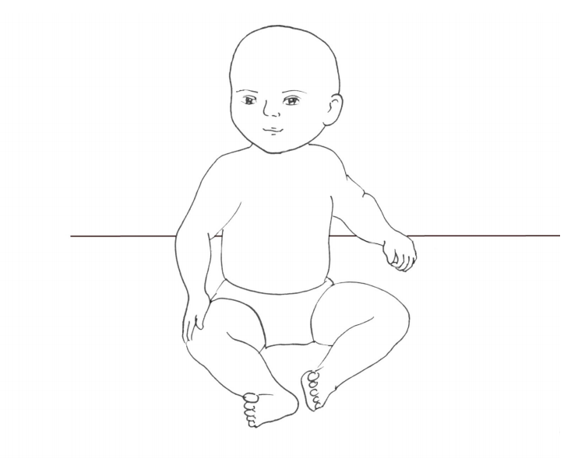 | Yes | No | DK
B6 | Does the child look at an object when someone says "look!" and points to it? |  | Yes | No | DK
B7 | Can the child pick up and eat small pieces of food with his/her fingers? | 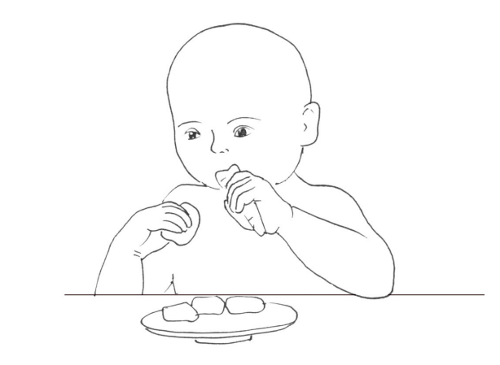 | Yes | No | DK
B8 | Can the child crawl, roll, or scoot forward on his/her own? | 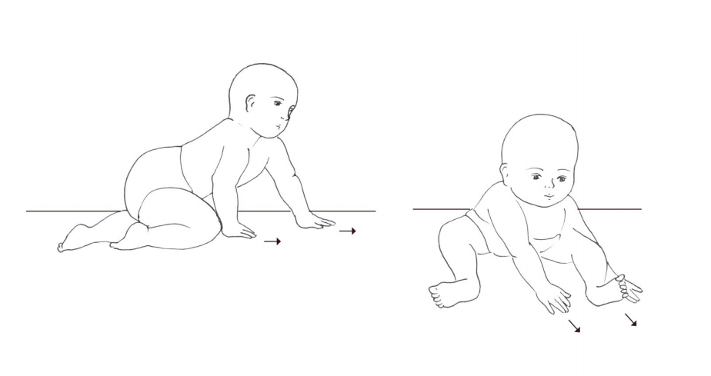 | Yes | No | DK
B9 | Can the child transfer a small object (e.g., a small toy or small stone) from one hand to the other? | 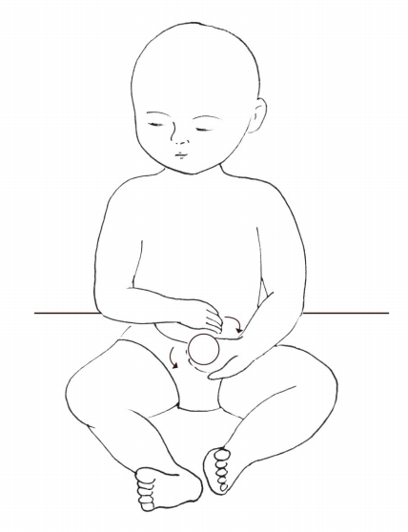 | Yes | No | DK
B10 | Can the child use gestures to indicate what he/she wants (e.g., put arms up to indicate that he/she wants to be held, or point to water)? |  | Yes | No | DK
B11 | Can the child pick up and drop a small object (e.g., a small toy or small stone) into a bucket or bowl while sitting? | 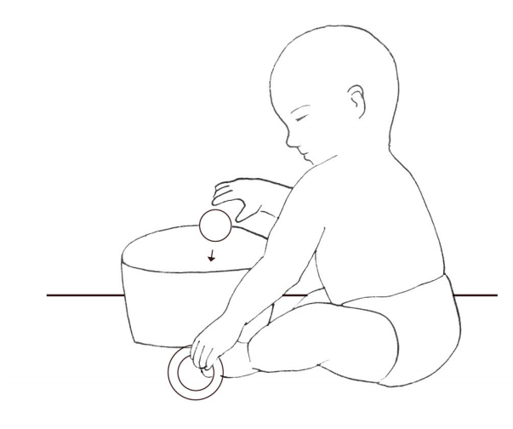 | Yes | No | DK
B12 | Can the child throw a small ball or small stone in a forward direction using his/her hand? | 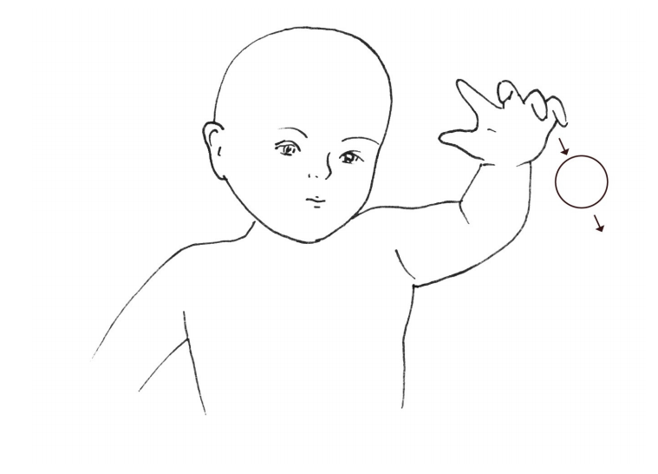 | Yes | No | DK
B13 | Can the child say one or more words (e.g., names like "Mama" or "ba" for "ball")? |  | Yes | No | DK
B14 | Does the child ask you for help using signs or words when he/she cannot do something on his/her own (e.g., to reach an object up high)? |  | Yes | No | DK
B15 | Can the child walk several steps while holding on to a person or object (e.g., wall or furniture)? | 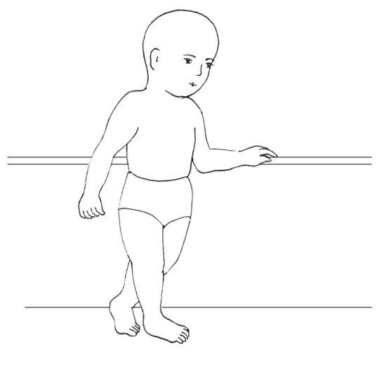 | Yes | No | DK
B16 | Can the child follow simple directions (e.g., “Stand up" or "Come here”)? |  | Yes | No | DK
B17 | Can the child maintain a standing position on his/her own, without holding on or receiving support? | 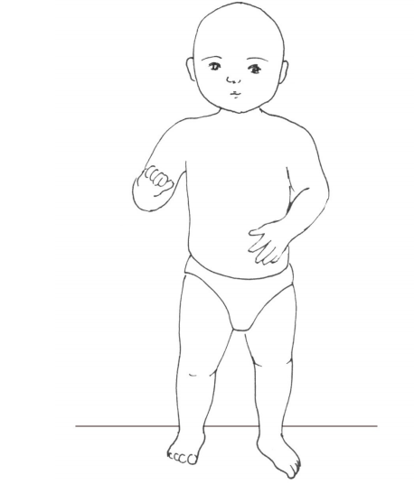 | Yes | No | DK
B18 | Can the child point to a person or object when asked (e.g., “Where is mama?" or "Where is the ball?")? |  | Yes | No | DK
B19 | Can the child climb onto an object such as a chair or bench? | 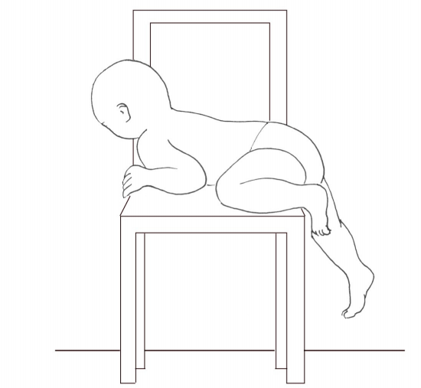 | Yes | No | DK
B20 | Can the child kick a ball or other round object forward using his/her foot? | 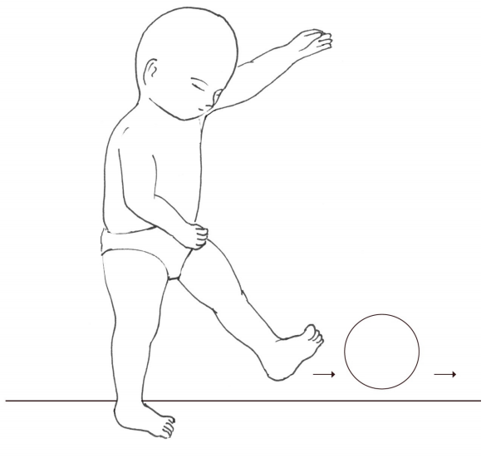 | Yes | No | DK

Caregiver Reported Early Development InstrumentS (CREDI)

Short Form: 12-17 MONTHS

Date: _____________________________
Interviewee ID: _____________________
Child Date of Birth: __________________
Child Age (in Months): _______________

Assessor Instructions:

- Administer the set of questions that corresponds with the child’s age band.
- Remember to show caregivers the corresponding full-page illustration for those items that include an image.
- Before administering items, SAY (to caregivers):
Now I am going to ask you about the types of things your child is currently able to do. Please answer "yes" or "no" to these questions. If you are unsure, you can also answer by saying “don’t know.” Please keep in mind that children learn and grow at different rates, so it is fine if your child can't yet do these things. Some of these skills children only achieve at older ages. If there is any question you feel uncomfortable answering, please let me know and we can move to the next question.

Item # | Item | Image | Response
C1 | Can the child maintain a standing position on his/her own, without holding on or receiving support? | 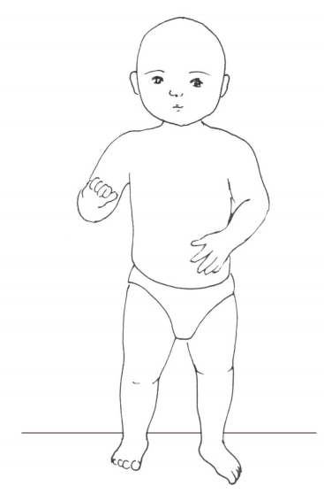 | Yes | No | DK
C2 | Can the child follow simple directions (e.g., “Stand up" or "Come here”)? |  | Yes | No | DK
C3 | Does the child imitate others' behaviors (e.g., washing hands or dishes)? |  | Yes | No | DK
C4 | Can the child climb onto an object such as a chair or bench? |  | Yes | No | DK
C5 | Is the child kind to younger children (e.g., speaks to them nicely and touches them gently)? |  | Yes | No | DK
C6 | Does the child show curiosity to learn new things (e.g., by asking questions or exploring a new area)? |  | Yes | No | DK
C7 | Can the child point to a person or object when asked (e.g., “Where is mama?" or "Where is the ball?")? |  | Yes | No | DK
C8 | Can the child kick a ball or other round object forward using his/her foot? |  | Yes | No | DK
C9 | Does the child involve others in play (i.e., play interactive games with other children)? |  | Yes | No | DK
C10 | Does the child show sympathy or look concerned when others are hurt or sad? |  | Yes | No | DK
C11 | Can the child run more than a few steps without falling or bumping into objects? | 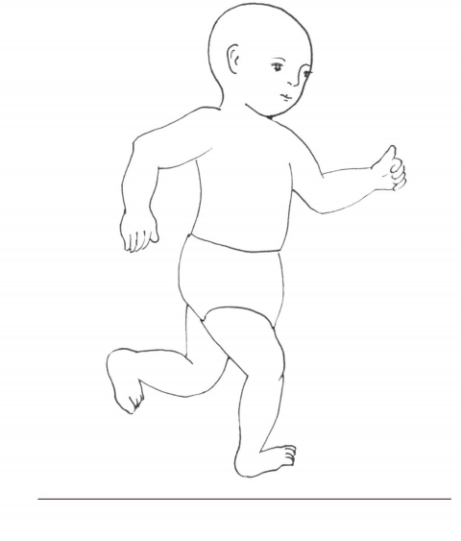 | Yes | No | DK
C12 | Can the child drink from a cup (without a lid) on his/her own without spilling? | 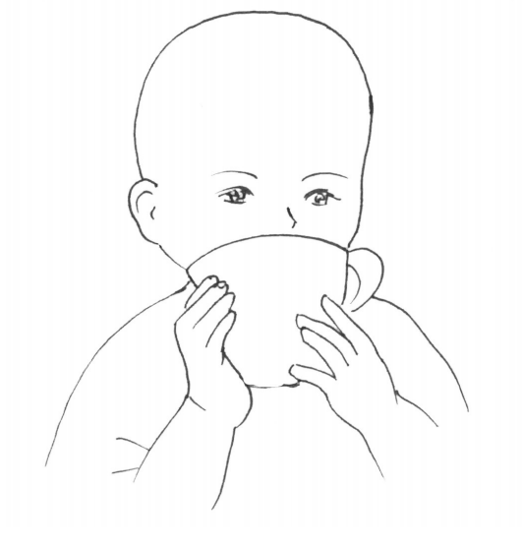 | Yes | No | DK
C13 | Can the child stack three or more small objects (e.g., blocks, cups, bottle caps) on top of each other? | 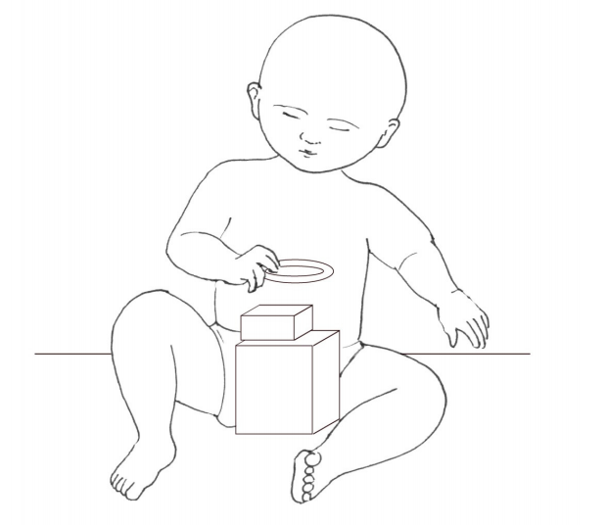 | Yes | No | DK
C14 | Can the child answer simple questions (e.g., “Do you want water?”) by saying "yes" or "no", rather than nodding? |  | Yes | No | DK
C15 | Does the child play by pretending objects are something else (e.g., imagining a bottle is a doll, a stone is a car, or a spoon is an airplane)? |  | Yes | No | DK
C16 | Can the child correctly name at least one family member other than mom and dad (e.g., name of brother, sister, aunt, uncle)? |  | Yes | No | DK
C17 | Can the child ask for something (e.g., food, water) by name when he/she wants it? |  | Yes | No | DK
C18 | Can the child walk backwards? | 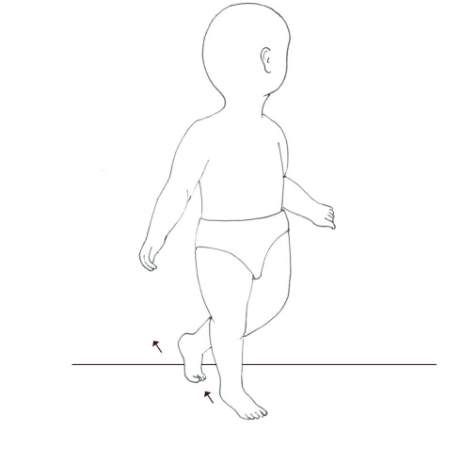 | Yes | No | DK
C19 | If you show the child an object he/she knows well (e.g., a cup or animal), can he/she consistently name it? |  | Yes | No | DK
C20 | Can the child say ten or more separate words (e.g., names like "Mama" or objects like "ball")? |  | Yes | No | DK

Caregiver Reported Early Development InstrumentS (CREDI)

Short Form: 18-23 MONTHS

Date: _____________________________
Interviewee ID: _____________________
Child Date of Birth: __________________
Child Age (in Months): _______________

Assessor Instructions:

- Administer the set of questions that corresponds with the child’s age band.
- Remember to show caregivers the corresponding full-page illustration for those items that include an image.
- Before administering items, SAY (to caregivers):
Now I am going to ask you about the types of things your child is currently able to do. Please answer "yes" or "no" to these questions. If you are unsure, you can also answer by saying “don’t know.” Please keep in mind that children learn and grow at different rates, so it is fine if your child can't yet do these things. Some of these skills children only achieve at older ages. If there is any question you feel uncomfortable answering, please let me know and we can move to the next question.

Item # | Item | Image | Response
D1 | Can the child walk backwards? |  | Yes | No | DK
D2 | Can the child ask for something (e.g., food, water) by name when he/she wants it? |  | Yes | No | DK
D3 | Can the child correctly name at least one family member other than mom and dad (e.g., name of brother, sister, aunt, uncle)? |  | Yes | No | DK
D4 | If you show the child an object he/she knows well (e.g., a cup or animal), can he/she consistently name it? |  | Yes | No | DK
D5 | Can the child remove an item of clothing (e.g., take off his/her shirt)? | 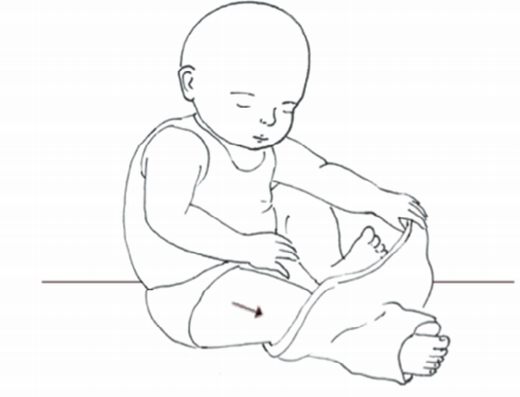 | Yes | No | DK
D6 | Can the child say ten or more separate words (e.g., names like "Mama" or objects like "ball")? |  | Yes | No | DK
D7 | Can the child tell you when he/she is tired or hungry? |  | Yes | No | DK
D8 | Can the child sing a short song or repeat parts of a rhyme from memory by him/herself? |  | Yes | No | DK
D9 | Can the child jump with both feet leaving the ground? | 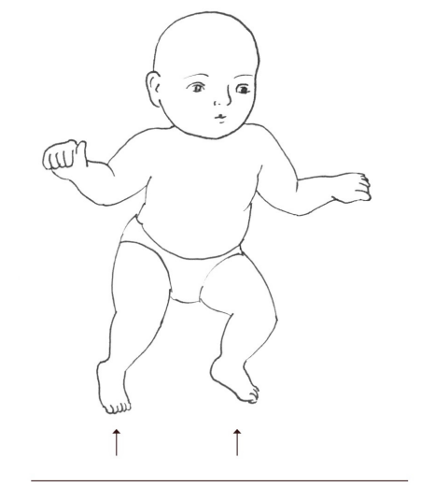 | Yes | No | DK
D10 | Can the child correctly use any of the words "I," "you," "she," or "he" (e.g., "I go to store," or "He eats rice")? |  | Yes | No | DK
D11 | Can the child correctly ask questions using any of the words "what," "which," "where," or "who"? |  | Yes | No | DK
D12 | Can the child count up to five objects (e.g., fingers, people)? |  | Yes | No | DK
D13 | Can the child speak using sentences of three or more words that go together (e.g., "I want water" or "The house is big")? |  | Yes | No | DK
D14 | If you show the child two objects or people of different size, can he/she tell you which one is the big one and which is the small one? |  | Yes | No | DK
D15 | Can the child identify at least one color (e.g., red, blue, yellow)? |  | Yes | No | DK
D16 | Can the child explain in words what common objects like a cup or chair are used for? |  | Yes | No | DK
D17 | If you ask the child to give you three objects (e.g., stones, beans), does the child give you the correct amount? |  | Yes | No | DK
D18 | If you point to an object, can the child correctly use the words "on," "in," or "under" to describe where it is (e.g., "The cup is on the table" instead of "The cup is in the table."). |  | Yes | No | DK
D19 | Does the child ask about familiar people other than parents when they are not there (e.g., "Where is the neighbor?")? |  | Yes | No | DK
D20 | Does the child ask "why" questions (e.g., "Why are you tall?")? |  | Yes | No | DK

Caregiver Reported Early Development InstrumentS (CREDI)

Short Form: 24-29 MONTHS

Date: _____________________________
Interviewee ID: _____________________
Child Date of Birth: __________________
Child Age (in Months): _______________

Assessor Instructions:

- Administer the set of questions that corresponds with the child’s age band.
- Remember to show caregivers the corresponding full-page illustration for those items that include an image.
- Before administering items, SAY (to caregivers):
Now I am going to ask you about the types of things your child is currently able to do. Please answer "yes" or "no" to these questions. If you are unsure, you can also answer by saying “don’t know.” Please keep in mind that children learn and grow at different rates, so it is fine if your child can't yet do these things. Some of these skills children only achieve at older ages. If there is any question you feel uncomfortable answering, please let me know and we can move to the next question.

Item # | Item | Image | Response
E1 | If you show the child an object he/she knows well (e.g., a cup or animal), can he/she consistently name it? |  | Yes | No | DK
E2 | Can the child say ten or more separate words (e.g., names like "Mama" or objects like "ball")? |  | Yes | No | DK
E3 | Can the child sing a short song or repeat parts of a rhyme from memory by him/herself? |  | Yes | No | DK
E4 | Can the child jump with both feet leaving the ground? |  | Yes | No | DK
E5 | Can the child speak using sentences of three or more words that go together (e.g., "I want water" or "The house is big")? |  | Yes | No | DK
E6 | Can the child correctly ask questions using any of the words "what," "which," "where," or "who"? |  | Yes | No | DK
E7 | Can the child correctly use any of the words "I," "you," "she," or "he" (e.g., "I go to store," or "He eats rice")? |  | Yes | No | DK
E8 | Does the child ask about familiar people other than parents when they are not there (e.g., "Where is the neighbor?")? |  | Yes | No | DK
E9 | Can the child count up to five objects (e.g., fingers, people)? |  | Yes | No | DK
E10 | Can the child identify at least one color (e.g., red, blue, yellow)? |  | Yes | No | DK
E11 | Does the child often kick, bite, or hit other children or adults? |  | Yes | No | DK
E12 | If you show the child two objects or people of different size, can he/she tell you which one is the big one and which is the small one? |  | Yes | No | DK
E13 | Does the child become extremely withdrawn or shy in new situations? |  | Yes | No | DK
E14 | If you point to an object, can the child correctly use the words "on," "in," or "under" to describe where it is (e.g., "The cup is on the table" instead of "The cup is in the table."). |  | Yes | No | DK
E15 | Does the child ask "why" questions (e.g., "Why are you tall?")? |  | Yes | No | DK
E16 | If you ask the child to give you three objects (e.g., stones, beans), does the child give you the correct amount? |  | Yes | No | DK
E17 | Can the child explain in words what common objects like a cup or chair are used for? |  | Yes | No | DK
E18 | Can the child dress him/herself (e.g., put on his/her pants and shirt without help)? |  | Yes | No | DK
E19 | Can the child say what others like or dislike (e.g., "Mama doesn't like fruit," "Papa likes football")? |  | Yes | No | DK
E20 | Can the child talk about things that have happened in the past using correct language (e.g., "Yesterday I played with my friend" or "Last week she went to the market")? |  | Yes | No | DK

Caregiver Reported Early Development InstrumentS (CREDI)

Short Form: 30-35 MONTHS

Date: _____________________________
Interviewee ID: _____________________
Child Date of Birth: __________________
Child Age (in Months): _______________

Assessor Instructions:

- Administer the set of questions that corresponds with the child’s age band.
- Remember to show caregivers the corresponding full-page illustration for those items that include an image.
- Before administering items, SAY (to caregivers):
Now I am going to ask you about the types of things your child is currently able to do. Please answer "yes" or "no" to these questions. If you are unsure, you can also answer by saying “don’t know.” Please keep in mind that children learn and grow at different rates, so it is fine if your child can't yet do these things. Some of these skills children only achieve at older ages. If there is any question you feel uncomfortable answering, please let me know and we can move to the next question.

Item # | Item | Image | Response
F1 | Can the child say ten or more separate words (e.g., names like "Mama" or objects like "ball")? |  | Yes | No | DK
F2 | Can the child jump with both feet leaving the ground? |  | Yes | No | DK
F3 | Can the child speak using sentences of three or more words that go together (e.g., "I want water" or "The house is big")? |  | Yes | No | DK
F4 | Can the child sing a short song or repeat parts of a rhyme from memory by him/herself? |  | Yes | No | DK
F5 | Can the child correctly ask questions using any of the words "what," "which," "where," or "who"? |  | Yes | No | DK
F6 | Does the child ask about familiar people other than parents when they are not there (e.g., "Where is the neighbor?")? |  | Yes | No | DK
F7 | Can the child correctly use any of the words "I," "you," "she," or "he" (e.g., "I go to store," or "He eats rice")? |  | Yes | No | DK
F8 | Can the child count up to five objects (e.g., fingers, people)? |  | Yes | No | DK
F9 | Can the child identify at least one color (e.g., red, blue, yellow)? |  | Yes | No | DK
F10 | If you show the child two objects or people of different size, can he/she tell you which one is the big one and which is the small one? |  | Yes | No | DK
F11 | If you point to an object, can the child correctly use the words "on," "in," or "under" to describe where it is (e.g., "The cup is on the table" instead of "The cup is in the table.") |  | Yes | No | DK
F12 | Can the child explain in words what common objects like a cup or chair are used for? |  | Yes | No | DK
F13 | Can the child dress him/herself (e.g., put on his/her pants and shirt without help)? |  | Yes | No | DK
F14 | Does the child ask "why" questions (e.g., "Why are you tall?")? |  | Yes | No | DK
F15 | If you ask the child to give you three objects (e.g., stones, beans), does the child give you the correct amount? |  | Yes | No | DK
F16 | Does the child often kick, bite, or hit other children or adults? |  | Yes | No | DK
F17 | Does the child become extremely withdrawn or shy in new situations? |  | Yes | No | DK
F18 | Does the child frequently act impulsively or without thinking (e.g., running into the street without looking)? |  | Yes | No | DK
F19 | Can the child say what others like or dislike (e.g., "Mama doesn't like fruit," "Papa likes football")? |  | Yes | No | DK
F20 | Can the child talk about things that have happened in the past using correct language (e.g., "Yesterday I played with my friend" or "Last week she went to the market")? |  | Yes | No | DK

